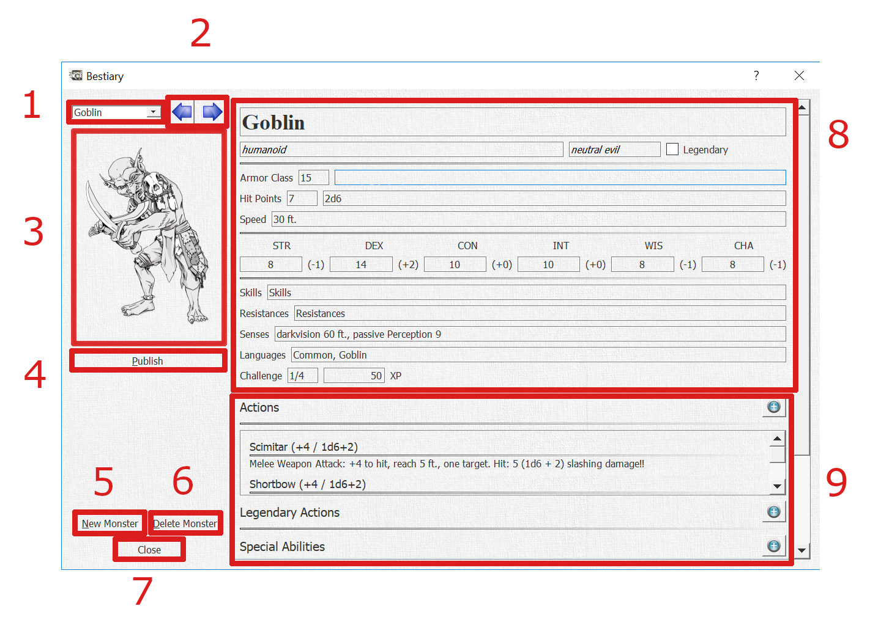

1. Monster selection drop-down

Here you can select an individual monster in the bestiary, either through the drop-down box or by typing the name of the monster. The names are listed in the drop-down alphabetically.

1. Monster selection arrows

Click to move left/right through the bestiary as if turning the pages of a book.

1. Monster image

This is the image icon used for this specific monster through the DM Helper application.

You can set the icon by:

1. Adding an image to the directory in which the bestiary is stored or its /Images subdirectory with the same name as the monster. Files with both the .jpg and .png extension are supported.
2. Click on the image and select an image file from your local file system.

Once the icon has been set, it’s relative location to the bestiary will be stored. To replace it you need to click on the image and select a new image file.

1. Publish button

Publishes the monster image in the Player Publish Window, useful for demonstrating how a monster looks in its full glory to your players!

1. New Monster button

Creates a new, blank monster entry

1. Delete Monster button

Deletes the currently selected monster. Use with care!

1. Close button

Closes the bestiary dialog. Note: This does not unload the bestiary as it is used by the whole DM Helper application.

1. Monster Information

Editable details for the monster. The following individual details have a relevance in other parts of the DM Helper application:

* Monster size is used to set the size of monster icons in the Battle Dialog
* Armor Class is shown for reference in the Battle Dialog
* Speed is used to determine the allowed movement distance when “Limit Movement” is selected in the Battle Dialog
* Hit Points / Hit Dice: the average hit points are read-only and are calculated based on the entered hit dice
* Attribute bonuses are calculated based on the given attribute values
* Attributes and skills are used for saving throws when applying area effects in the Battle Dialog
* XP are used to evaluate the difficulty level of an encounter

1. Ability Lists

Actions, Legendary Actions, Special Abilities and Reactions are all shown in their own lists.

* To edit an individual action, double-click on it
* To add a new action, click the “plus” icon to the right of the list title
* To delete an action, double-click on it to open the edit dialog and click the “Delete Action” button